SIMATS ENGINEERING
ASSESSMENT TOOL 2

COURSE NAME: Database Management Systems
COURSE CODE: CSA05

COURSE OUTCOME COVERED
CO2: Apply the relational model, relational algebra, SQL query structures, and views
to solve database querying and data manipulation problems. (BL3, BL6)
Activity Tool : Scenario-Based Task (High)
Assessment Tool Weightage: 35%

QUESTIONS Total Marks: 50

1 Given the scenario of a School Management System, identify relations and write SQL to list all students with their class teacher and grade.
ANSWER:
Relations:
STUDENT(StudentID, StudentName, ClassID)
CLASS(ClassID, ClassName, TeacherID)
TEACHER(TeacherID, TeacherName)
GRADE(StudentID, Grade)

SQL Query:
SELECT S.StudentName,
C.ClassName,
T.TeacherName,
G.Grade
FROM STUDENT S
JOIN CLASS C
ON S.ClassID = C.ClassID
JOIN TEACHER T
ON C.TeacherID = T.TeacherID
JOIN GRADE G
ON S.StudentID = G.StudentID;
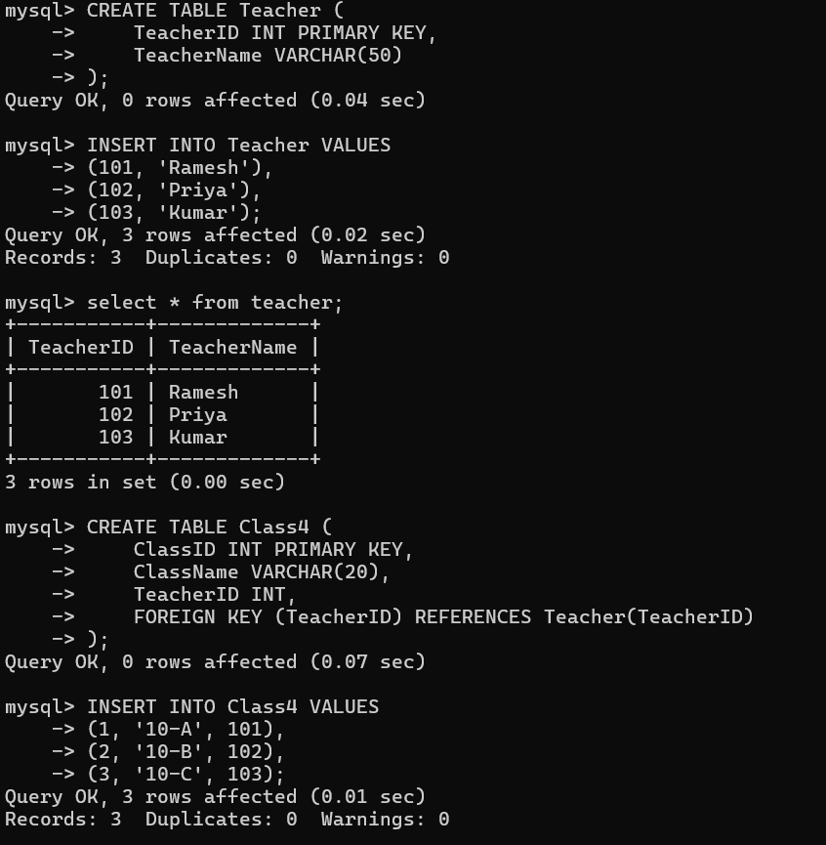
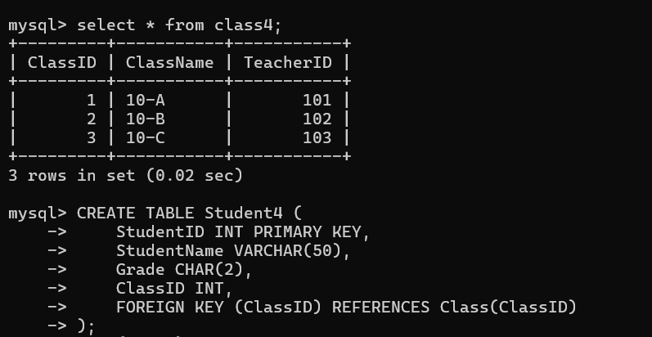
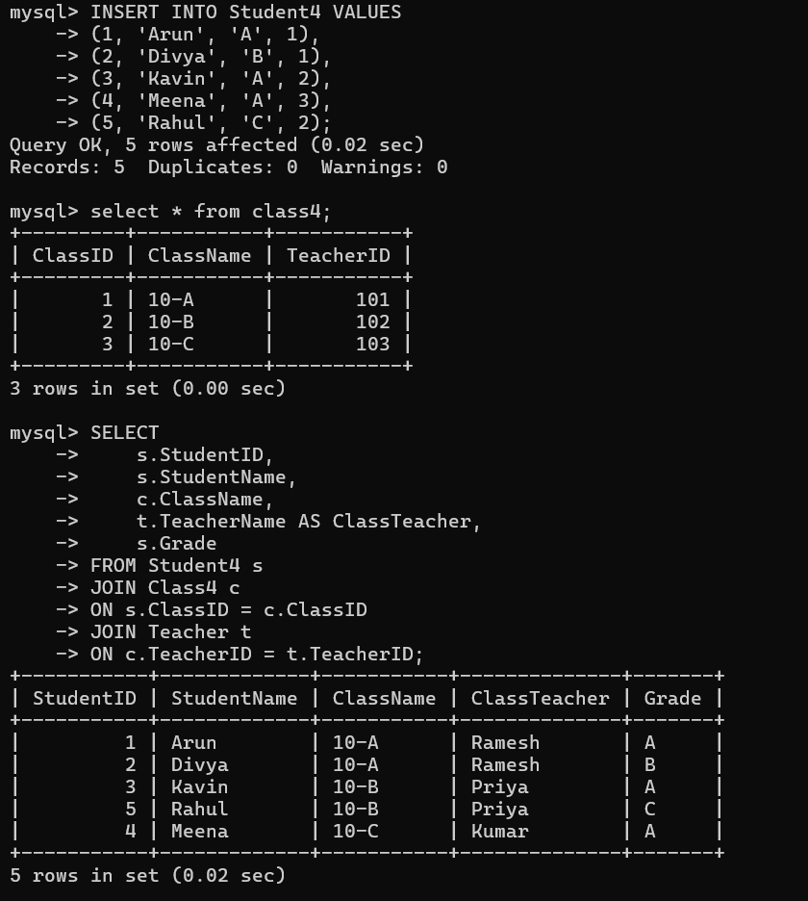

2 A hospital wants to track patient appointments. Design the relational schema and write SQL to find doctors with more than 10 appointments this month.
ANSWER:

Relational Schema:
PATIENT(PatientID, PatientName)
DOCTOR(DoctorID, DoctorName, Specialization)
APPOINTMENT(AppointmentID, PatientID, DoctorID, AppointmentDate)
SQL Query:
SELECT D.DoctorID,
D.DoctorName,
COUNT(A.AppointmentID) AS TotalAppointments
FROM DOCTOR D
JOIN APPOINTMENT A
ON D.DoctorID = A.DoctorID
WHERE MONTH(A.AppointmentDate) = MONTH(CURRENT_DATE)
AND YEAR(A.AppointmentDate) = YEAR(CURRENT_DATE)
GROUP BY D.DoctorID, D.DoctorName
HAVING COUNT(A.AppointmentID) > 10;
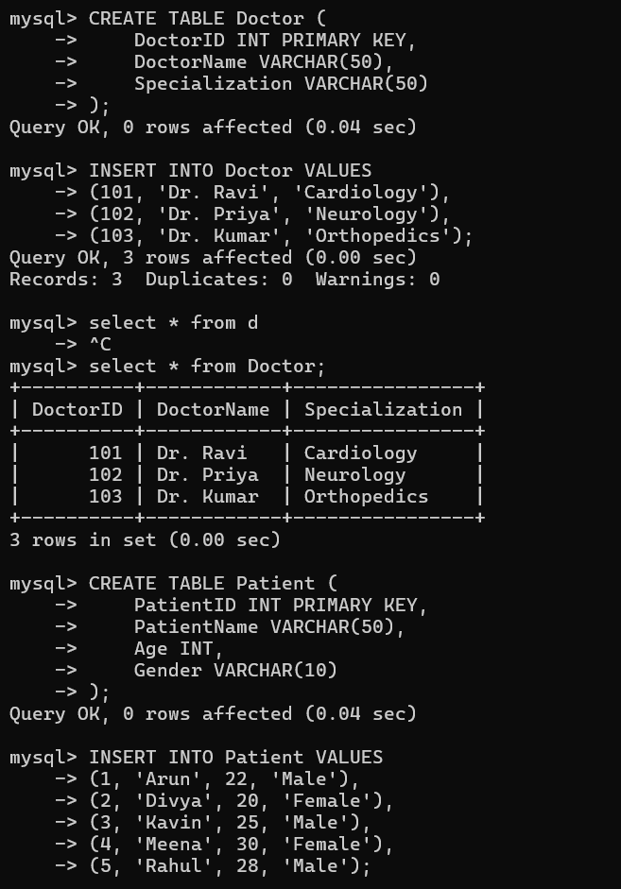
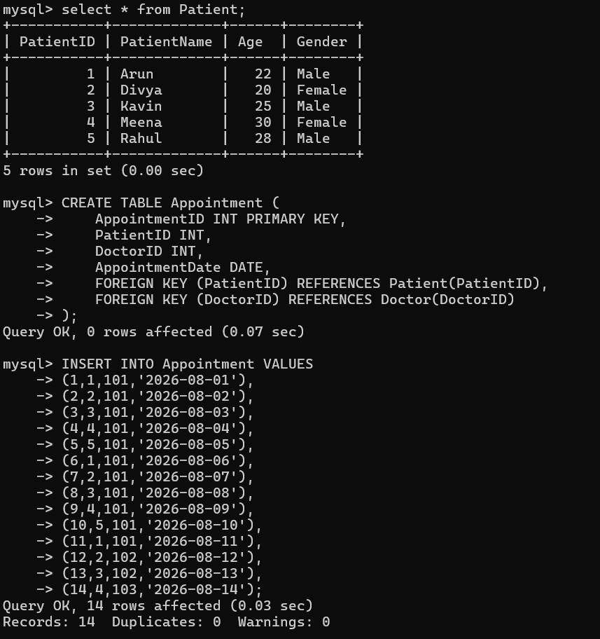
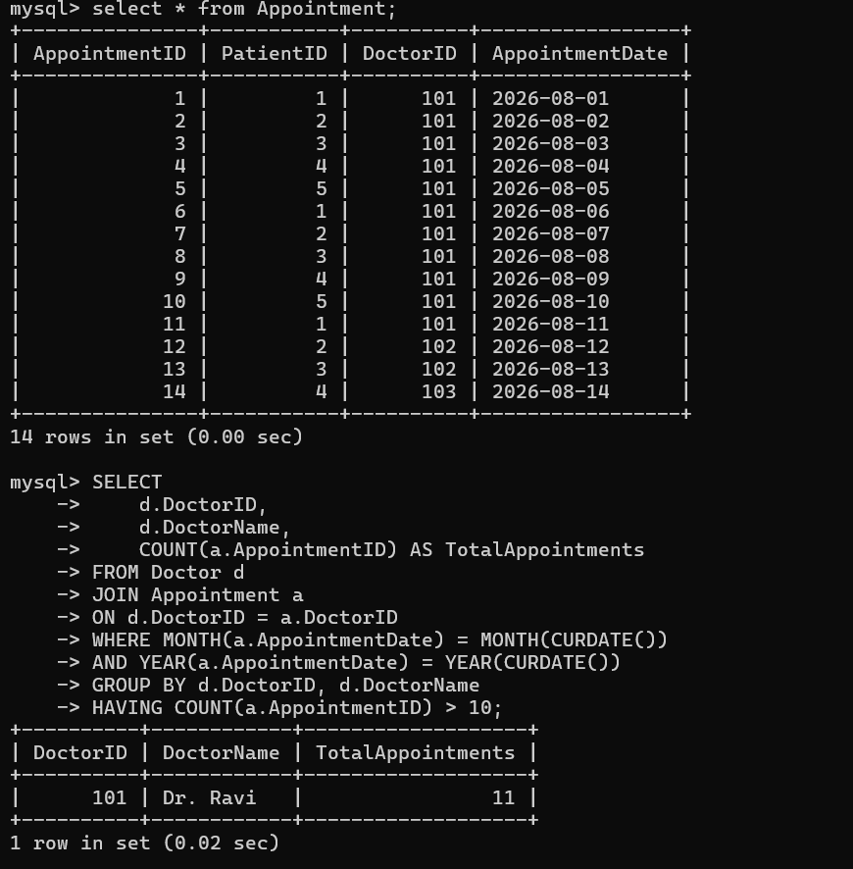

3 In an e-commerce scenario, write SQL queries using sub-queries to find products that have never been ordered.
ANSWER:
Relations:
PRODUCT(ProductID, ProductName)
ORDERS(OrderID)
ORDER_DETAILS(OrderID, ProductID)
SQL Query:
SELECT ProductID,
ProductName
FROM PRODUCT
WHERE ProductID NOT IN
(
SELECT ProductID
FROM ORDER_DETAILS
);

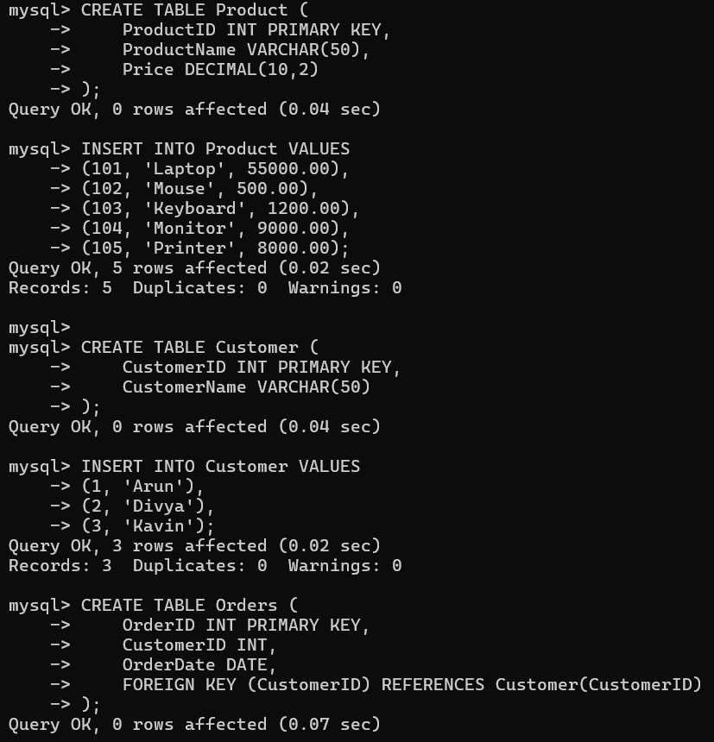
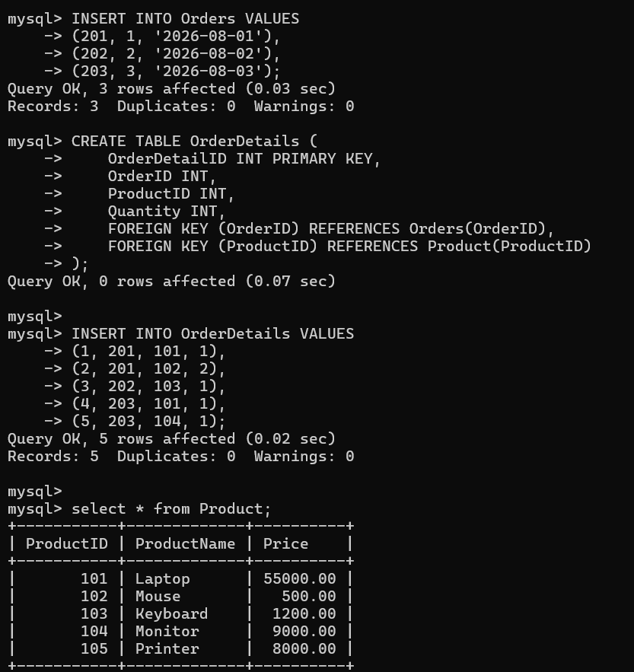
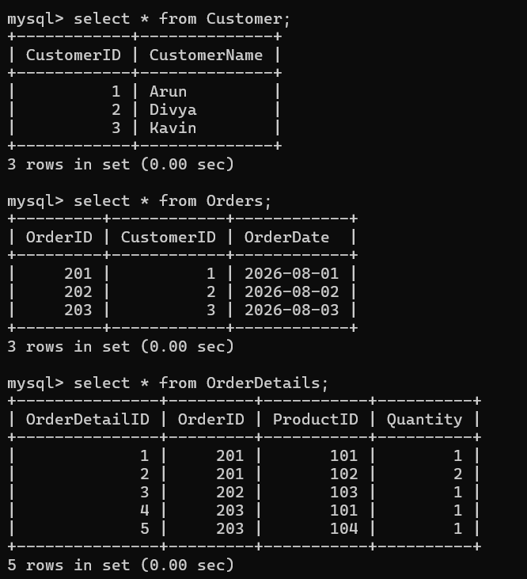
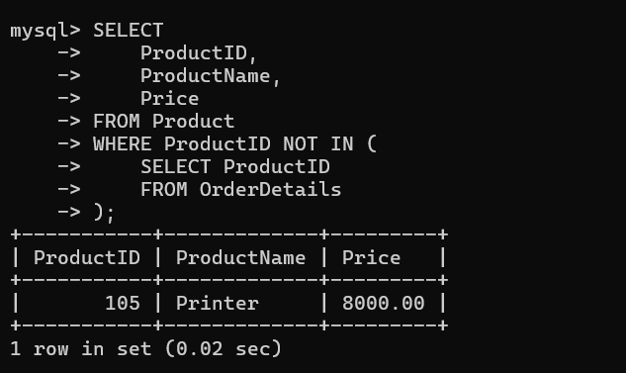
4 For a university database, write relational algebra expressions to find students enrolled in both ‘DBMS’ and ‘OS’ courses.
ANSWER:

Relations:
STUDENT(StudentID, StudentName)
COURSE(CourseID, CourseName)
ENROLLMENT(StudentID, CourseID)
Relational Algebra
Students enrolled in DBMS:
πStudentID
(
σCourseName='DBMS'
(COURSE ⋈ ENROLLMENT)
)
Students enrolled in OS
πStudentID
(
σCourseName='OS'
(COURSE ⋈ ENROLLMENT)
)
Students enrolled in both
πStudentID
(
σCourseName='DBMS'
(COURSE ⋈ ENROLLMENT)
)

∩

πStudentID
(
σCourseName='OS'
(COURSE ⋈ ENROLLMENT)
)

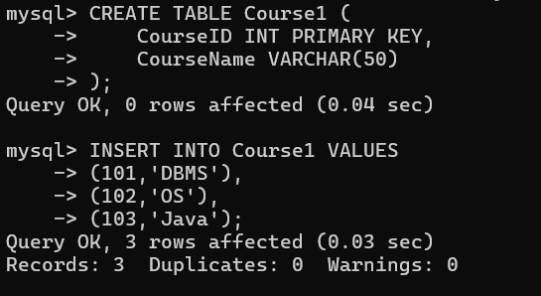
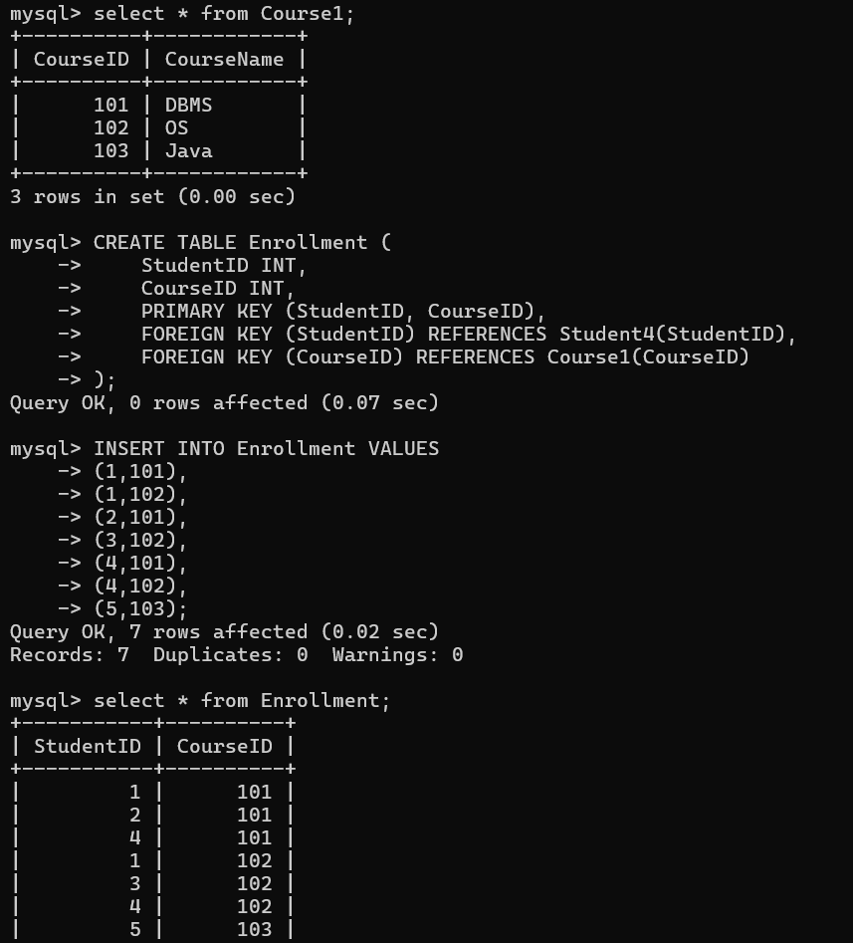
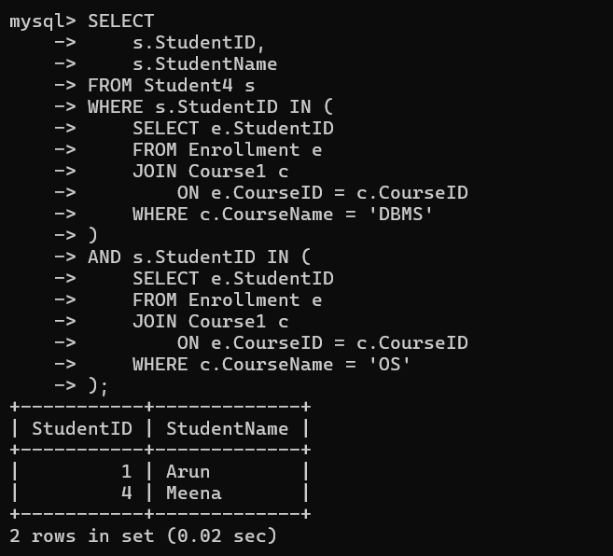
5 Given a payroll scenario, create a view showing employees whose salary is below department average and write a query to update their salary by 10%.
ANSWER:
Create View:
CREATE VIEW LowSalaryEmployees AS
SELECT E.EmpID,
E.EmpName,
E.DeptID,
E.Salary
FROM EMPLOYEE E
WHERE Salary <
(
SELECT AVG(Salary)
FROM EMPLOYEE X
WHERE X.DeptID = E.DeptID
);
Update Salary by 10%:
UPDATE EMPLOYEE
SET Salary = Salary * 1.10
WHERE EmpID IN
(
SELECT EmpID
FROM LowSalaryEmployees
);
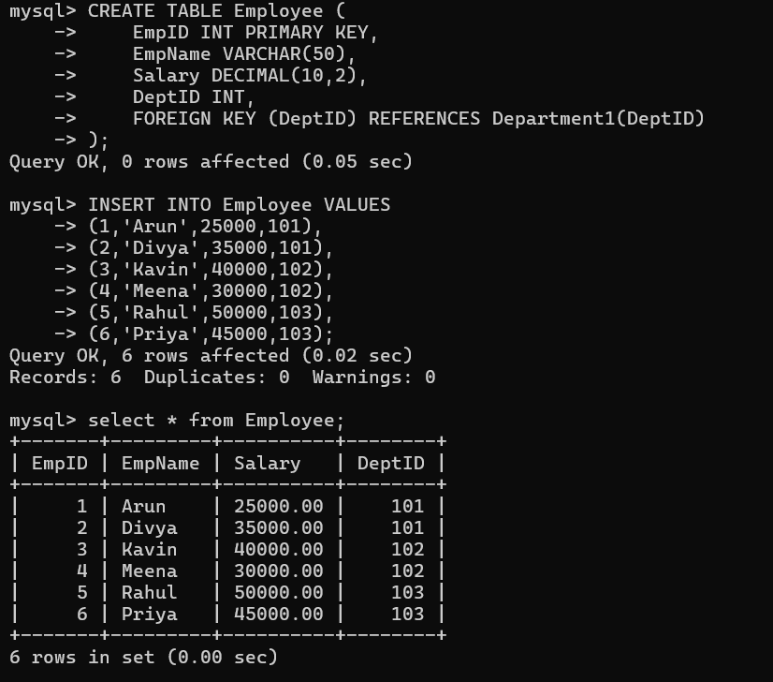
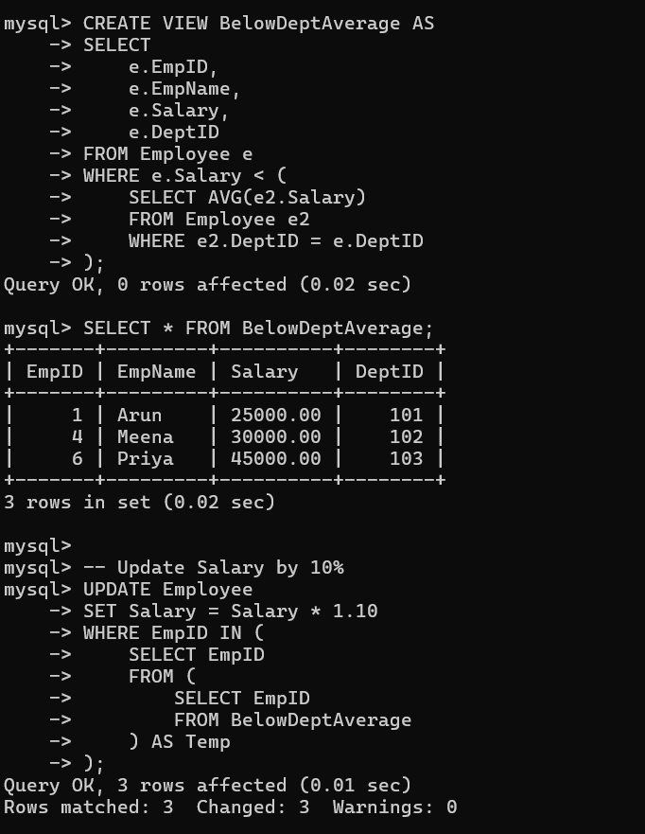
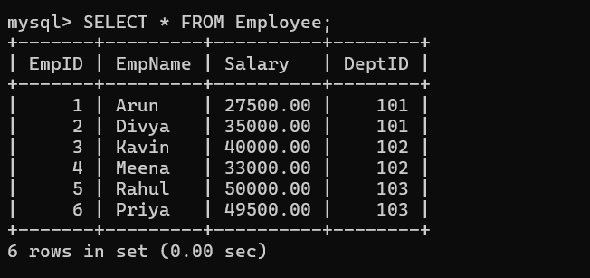
6 In a banking scenario, apply JOIN operations to retrieve customer account details, transaction history, and branch information.

ANSWER:
Relations:
CUSTOMER(CustomerID, CustomerName)
ACCOUNT(AccountNo, CustomerID, BranchID, Balance)
TRANSACTION(TransactionID, AccountNo, Amount, TransactionDate)
BRANCH(BranchID, BranchName)
SQL Query:
SELECT C.CustomerName,
A.AccountNo,
A.Balance,
T.TransactionID,
T.Amount,
T.TransactionDate,
B.BranchName
FROM CUSTOMER C
JOIN ACCOUNT A
ON C.CustomerID = A.CustomerID
JOIN TRANSACTION T
ON A.AccountNo = T.AccountNo
JOIN BRANCH B
ON A.BranchID = B.BranchID;
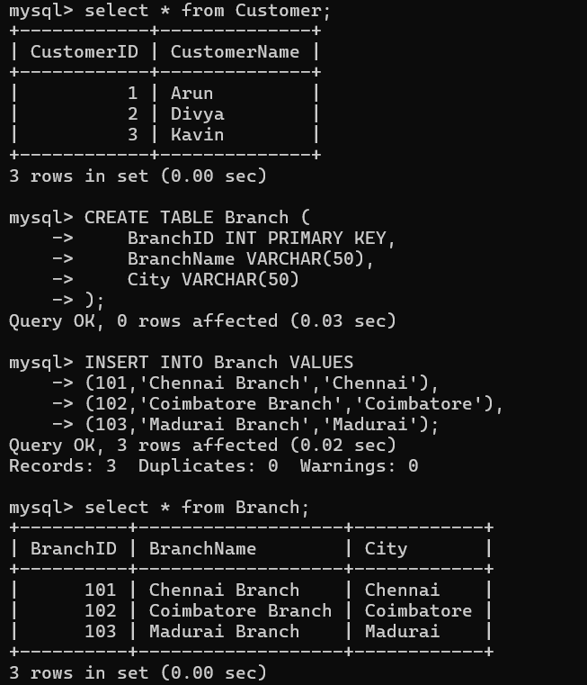
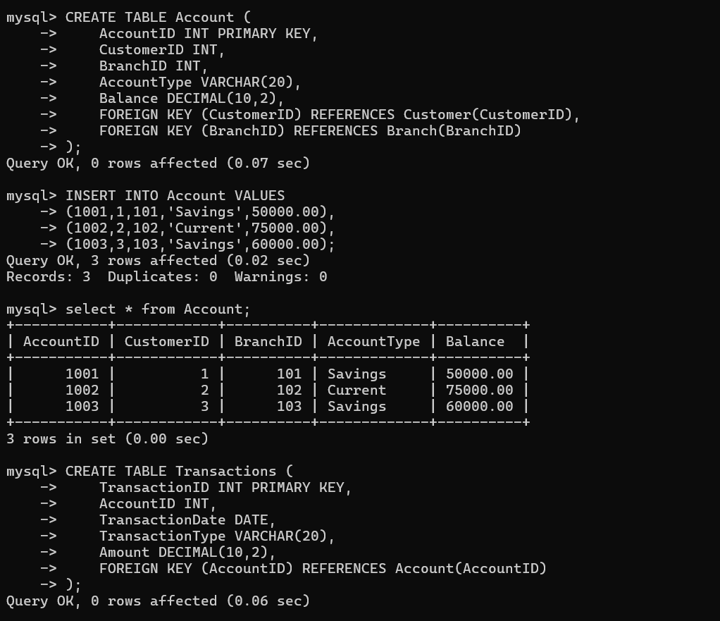
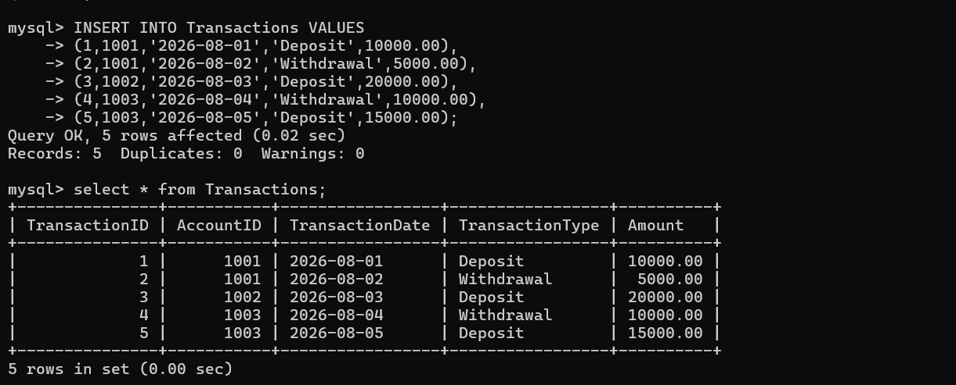
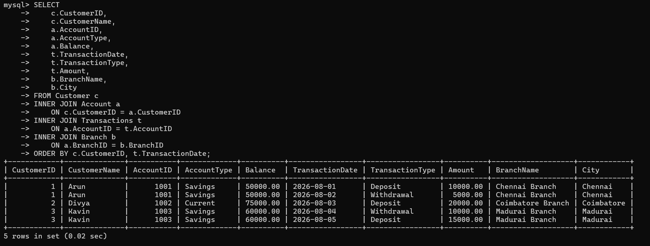
7 A retail store needs daily sales summary. Write SQL with GROUP BY and HAVING to report total sales per category exceeding Rs.10,000.
ANSWER:
Relations:
PRODUCT(ProductID, Category)
SALES(SaleID, ProductID, Amount)
SQL Query:
SELECT P.Category,
SUM(S.Amount) AS TotalSales
FROM PRODUCT P
JOIN SALES S
ON P.ProductID = S.ProductID
GROUP BY P.Category
HAVING SUM(S.Amount) > 10000;

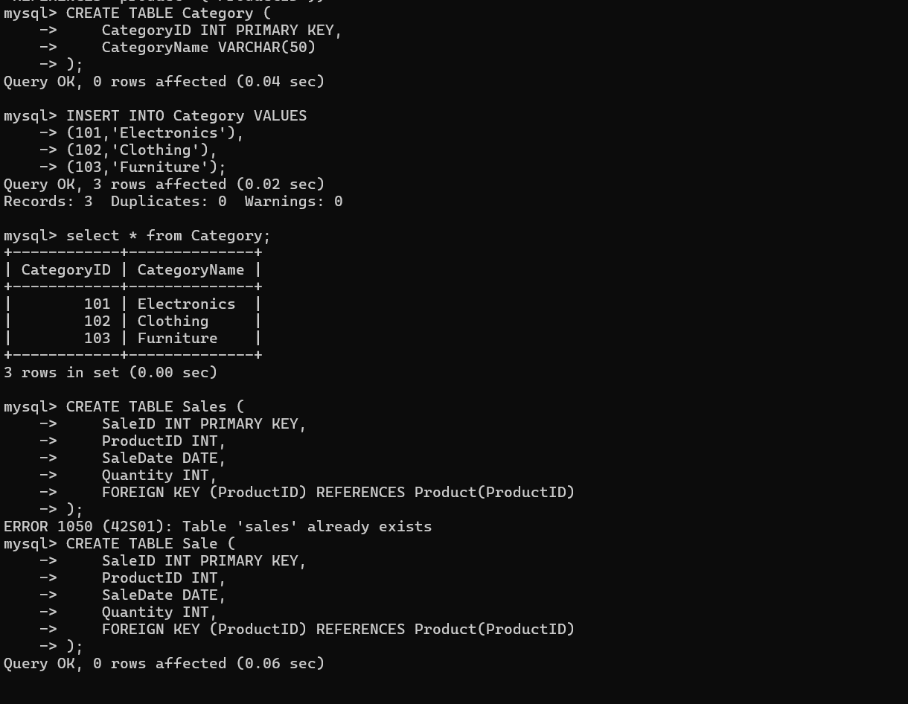
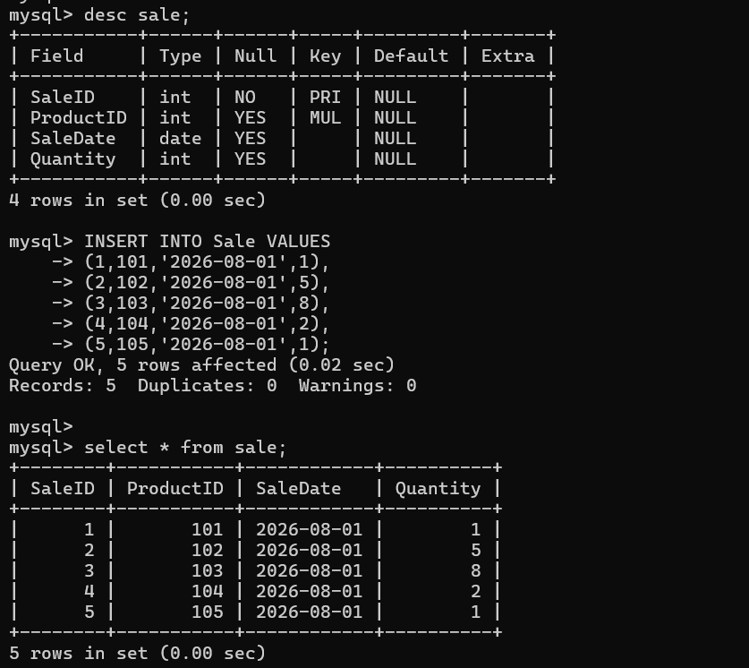
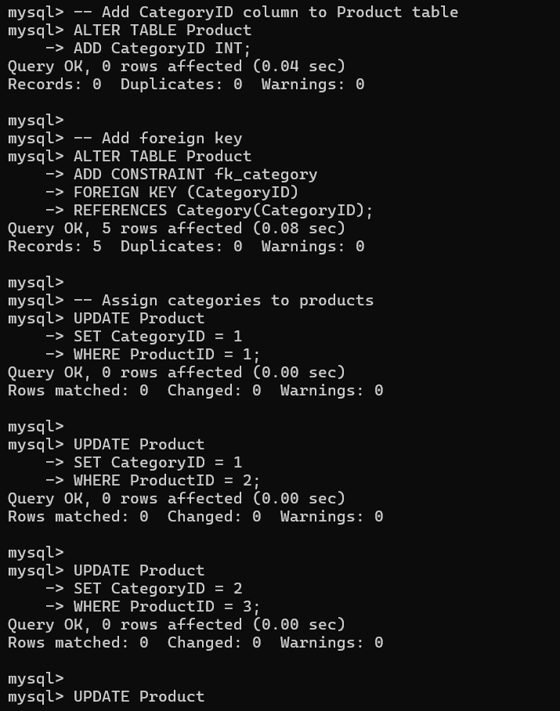
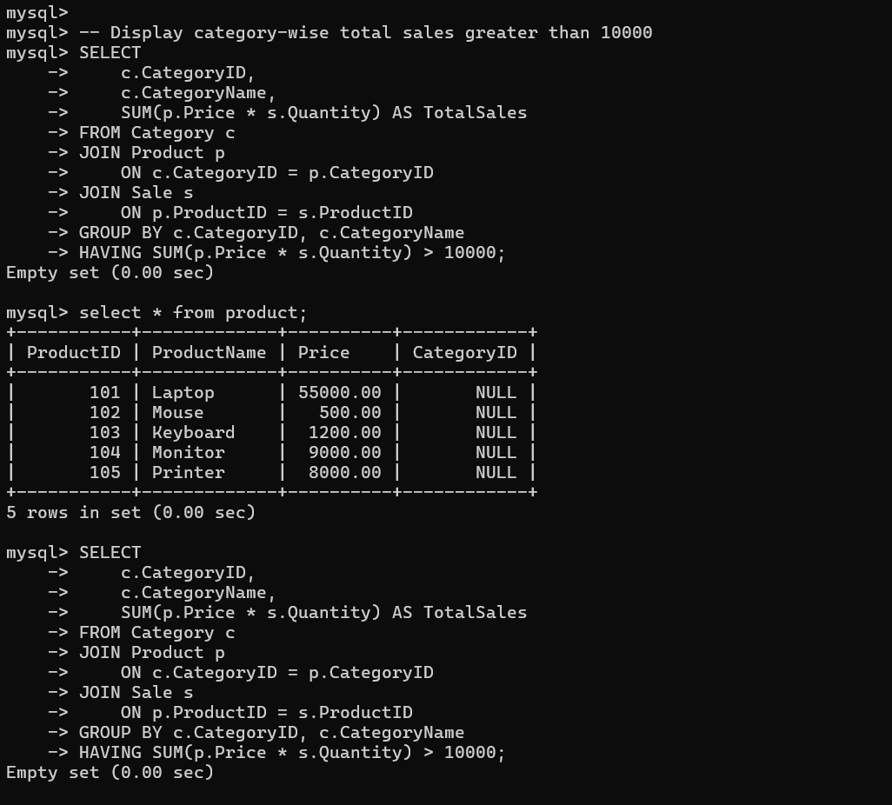
8 For a library system scenario, construct tuple relational calculus expressions to find members who borrowed books from all genres.
ANSWER:
Relations:
MEMBER(MemberID, Name)
BOOK(BookID, Genre)
BORROW(MemberID, BookID)
Tuple Relational Calculus:
{
M.Name |
MEMBER(M)
∧
∀G (
BOOK(G)
→
∃B (
BORROW(B)
∧ B.MemberID = M.MemberID
∧ B.BookID = G.BookID
)
)
}
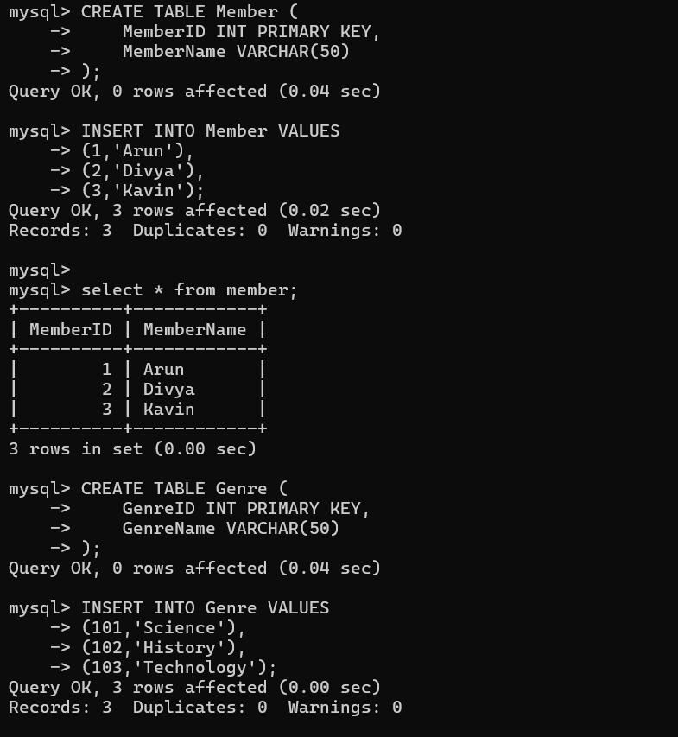
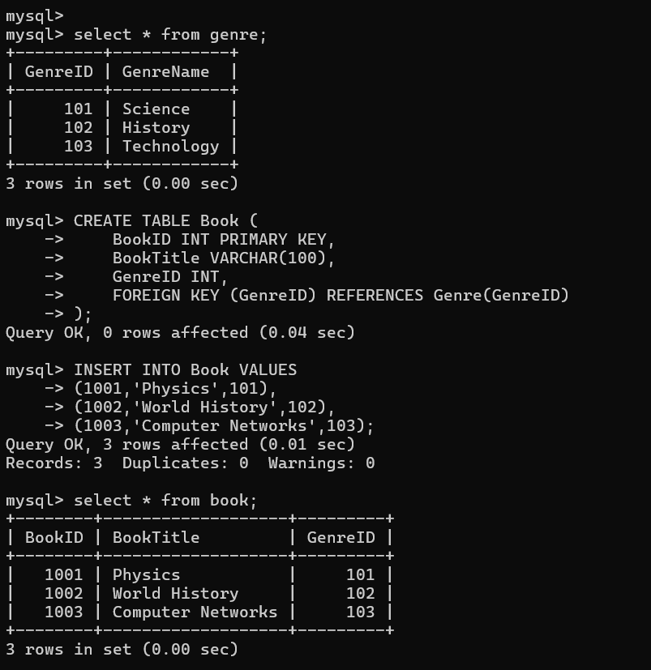
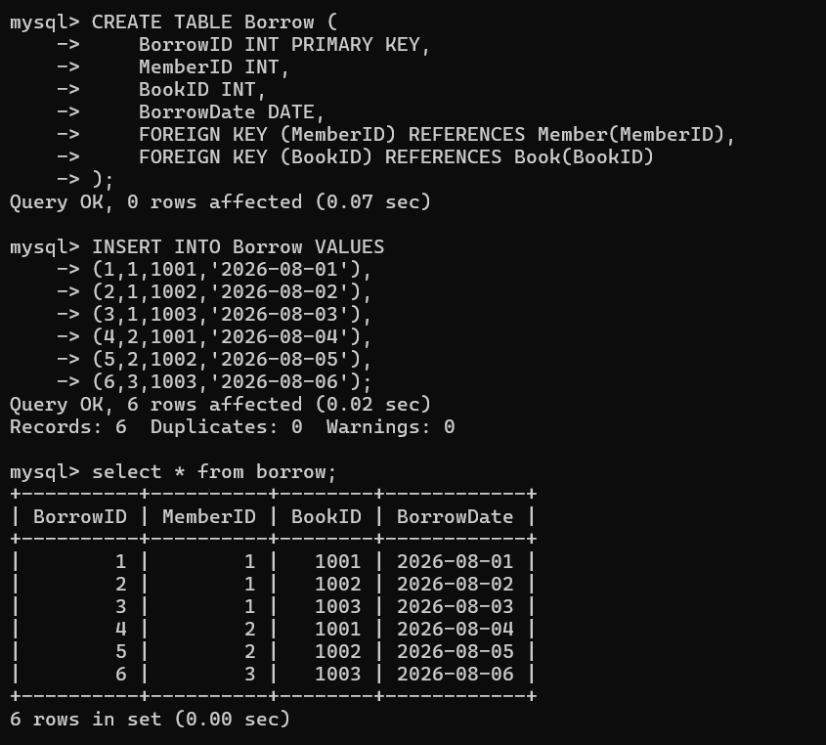
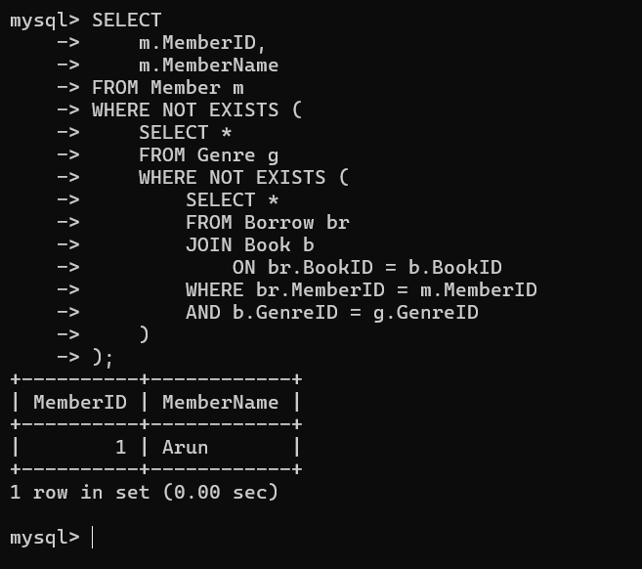

9 Given an inventory management scenario, define CHECK and FOREIGN KEY constraints and demonstrate their enforcement through SQL.
Create Tables:
CREATE TABLE CATEGORY
(
CategoryID INT PRIMARY KEY,
CategoryName VARCHAR(50)
);

CREATE TABLE PRODUCT
(
ProductID INT PRIMARY KEY,
ProductName VARCHAR(50),
Price DECIMAL(10,2) CHECK (Price > 0),
Stock INT CHECK (Stock >= 0),
CategoryID INT,
FOREIGN KEY(CategoryID)
REFERENCES CATEGORY(CategoryID)
);

Valid Insert:
INSERT INTO CATEGORY
VALUES(1,'Electronics');

INSERT INTO PRODUCT
VALUES(101,'Laptop',50000,20,1);

CHECK Constraint Violation:
INSERT INTO PRODUCT
VALUES(102,'Mouse',-500,10,1);
Result: Error because Price < 0

FOREIGN KEY Constraint Violation:
INSERT INTO PRODUCT
VALUES(103,'Keyboard',800,15,5);
Result: Error because CategoryID 5 does not exist

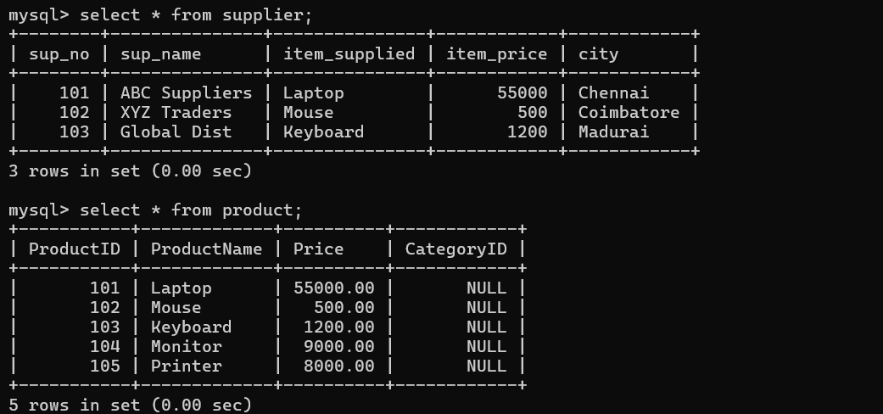
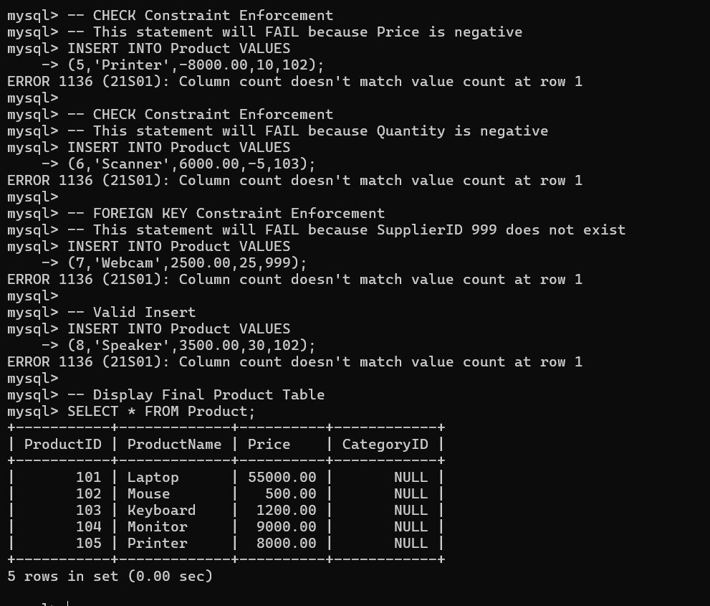

10 Design a relational schema for an HR system and create materialized views for monthly attendance and performance summaries.

ANSWER:
Relational Schema:

EMPLOYEE
(
EmpID,
EmpName,
DeptID
)

ATTENDANCE
(
AttendanceID,
EmpID,
AttendanceDate,
Status
)

PERFORMANCE
(
PerformanceID,
EmpID,
ReviewMonth,
Rating
)

Materialized View (Monthly Attendance):

CREATE MATERIALIZED VIEW MonthlyAttendance AS
SELECT EmpID,
COUNT(*) AS DaysPresent
FROM ATTENDANCE
WHERE Status='Present'
GROUP BY EmpID;

Materialized View (Performance Summary):

CREATE MATERIALIZED VIEW PerformanceSummary AS
SELECT EmpID,
AVG(Rating) AS AverageRating
FROM PERFORMANCE
GROUP BY EmpID;

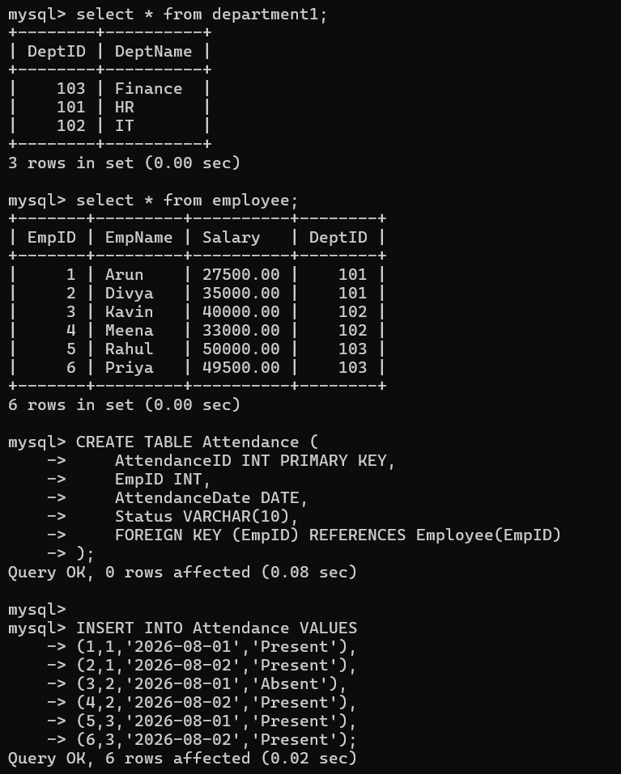
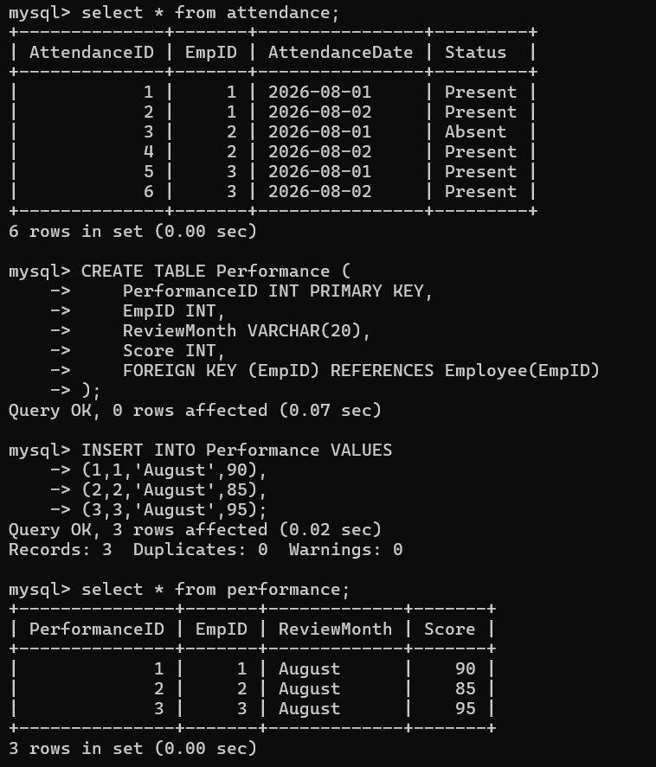
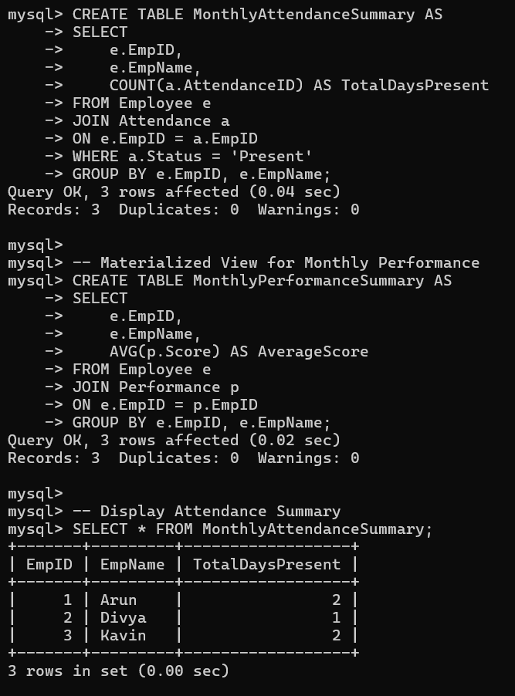
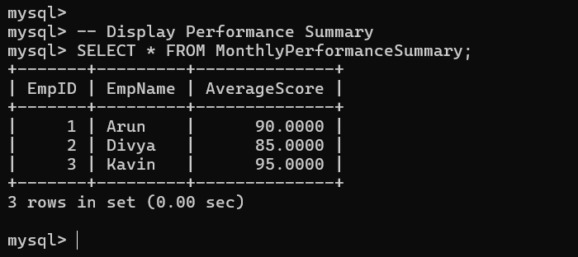

Code of Conduct:
I ____M.V.PREETHASHRI(192524476)___ (Name / Reg No) certify that this submission is my original work and that I have adhered to the guidelines specified for this assessment.
I understand that any violation of academic integrity rules will result in disciplinary action.
Signature of the student: M.V.PREETHASHRI

